Pathology Requesting Dashboard A+E Report December 2016

- Overall Requesting Costs
(Actual calculated costs from finance will differ and this should only be used as a guide for the purpose of this report)
£22575.67 Estimated spend on biochemistry/haematology/Immunology tests by HoEFT A+E for December 2016. (Includes Good Hope and Solihull)
- Cost this month (£22575.67) +13.9% from November (£19816) +2.9% from October (£21929)
- Patient Numbers this month (11851) +0.5% from November (11781) and -3.3% from October (12251).
- Request Numbers this month (35655) +11.9% from November (31856) and +2.2% from October (34881).
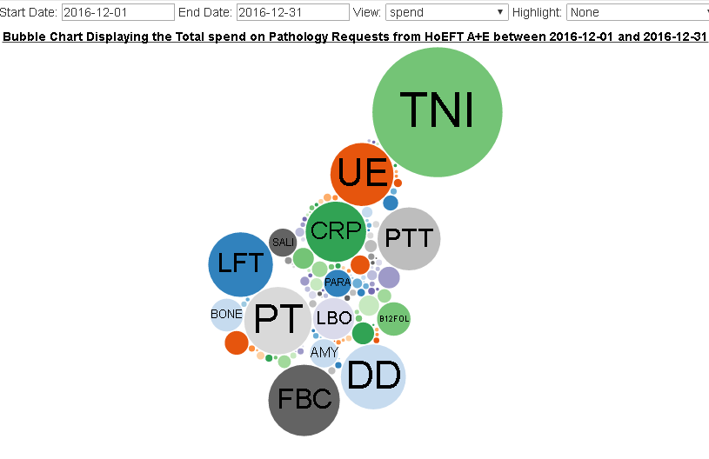
http://ebh24751:8000/graphs/costs_bubble/?start=2016-12-01&end=2016-12-31&view=spend&highlight=none
- Repeats
£85 was spend on A+E requests repeated within 180 minutes within A+E during December excluding troponin (£310 including) which is up from Novembers £74 (£235 including Troponin).
This only represents samples charged to A+E pathology twice, the actual figures for retesting between departments is much higher.
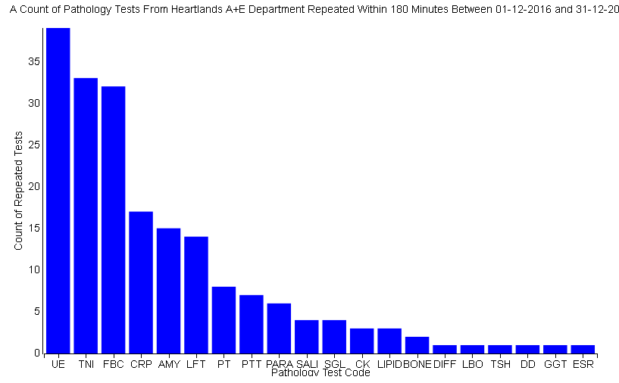
http://ebh24751:8000/graphs/repeats/?start=2016-12-01&end=2016-12-31&mins=180

- Add-on tests
£767 extra was charged to A+E in November for tests added on more than 4 hours after the initial test. This is an increase from the £753 extra added in November.
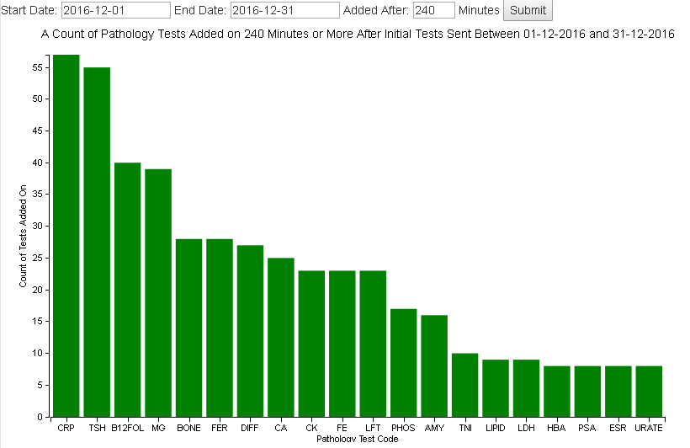
http://ebh24751:8000/graphs/addons/?start=2016-12-01&end=2016-12-31&mins=240
Investigating this in further detail we can see that the biggest cost comes from B12 and Folate addons (£119).
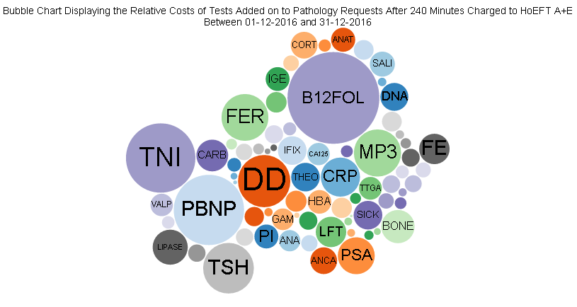
http://ebh24751:8000/graphs/addons/cost/?start=2016-12-01&end=2016-12-31&mins=240
- ICE Requesting
68% of A+E pathology requests made during November 2016 were made electronically through ICE requesting, an increase on the 67% seen in November.
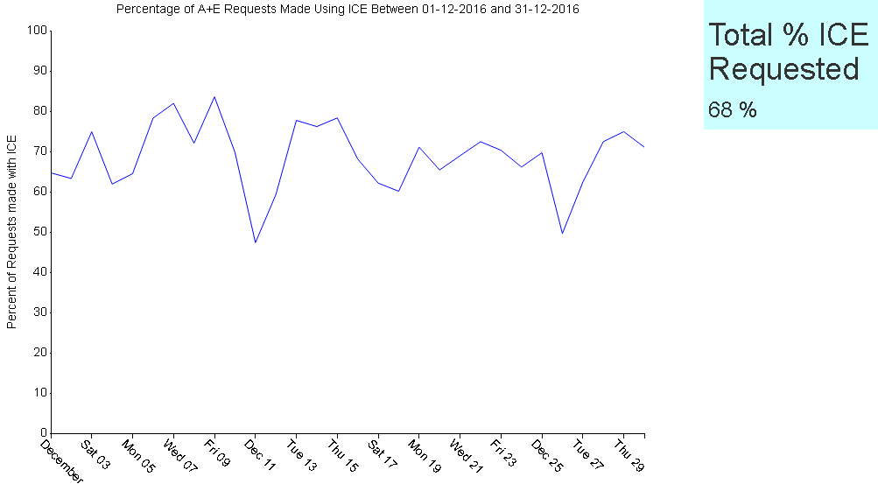
http://ebh24751:8000/graphs/ice_n/?start=2016-12-01&end=2016-12-31
- Investigating Bundles
Within ICE requesting for A+E there are several pre-defined testing bundles designed to be used for specific patient presentations. We have investigated the data we have with respect to these bundles to work out if anyone is using them.
The bundles we chose to investigate were ‘Acute Coronary Symptoms’, ‘First Fit’ and ‘Stroke’. Explanations of the calculations used to define patients groups were included in the October report which can be requested from pip.croxford@heartofengland.nhs.uk.

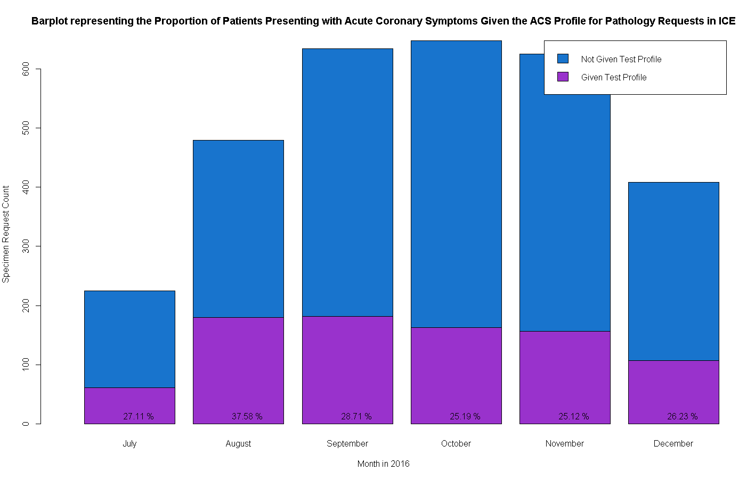

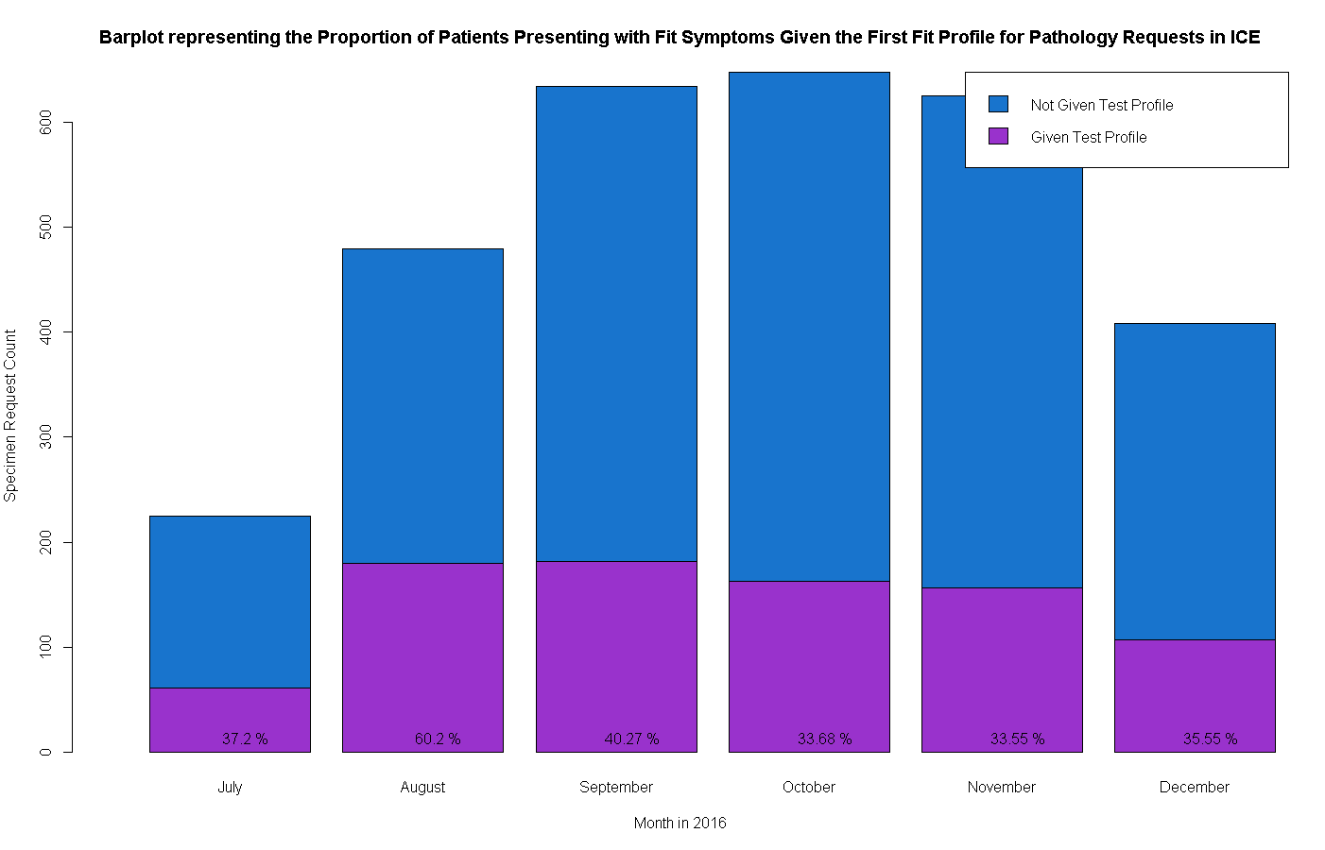

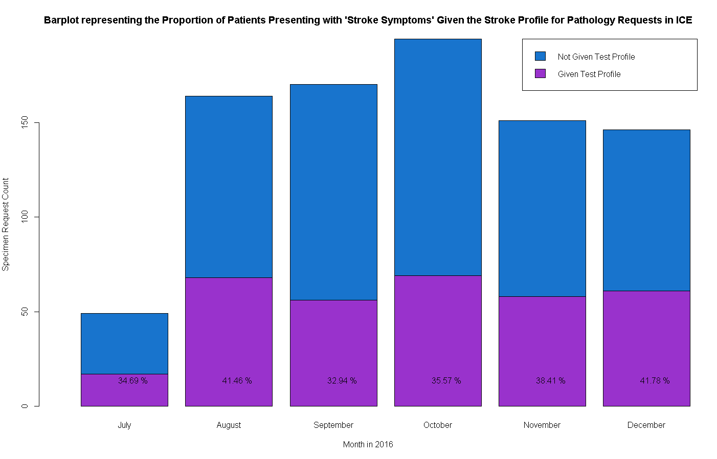
None of these bundles showed any particularly sgnificant increase or decrease in use this month.
- New Developments
A new data view has been created built upon the work for requesting levels done previously. We took the feedback from our requesting levels graph and replaced the clinician names with the individual tests.
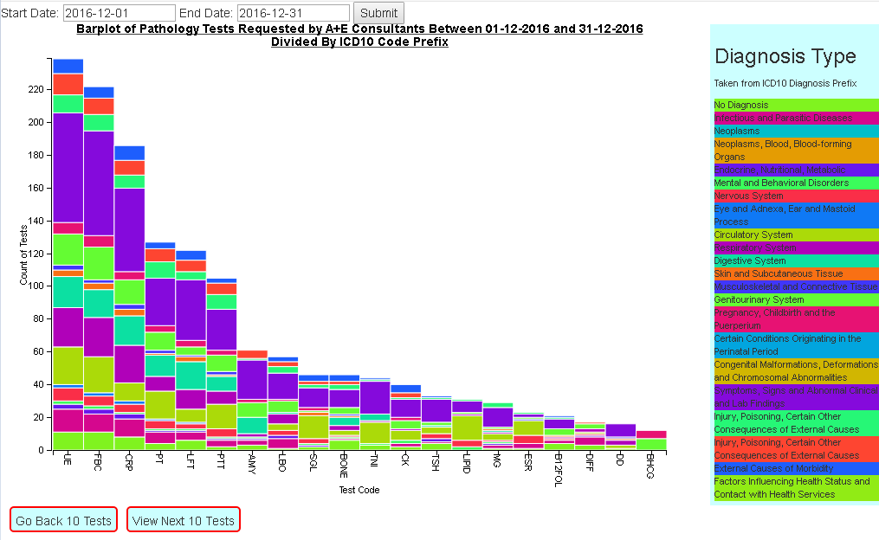
http://ebh24751:8000/graphs/icd_split/?start=2016-12-01&end=2016-12-31
Contact Details
This report was created by Pip Croxford as part of an MSc in Health Informatics for the University of Manchester. She will happily answer any questions and would be grateful for any feedback.
Email: pip.croxford@heartofengland.nhs.uk
Ext: 52956

